Project Synopsis

on

**Soil Testing and Crop Recommendation**

Submitted as a part of course curriculum for

**Bachelor of Technology**

in

**Computer Science**

n



**Sanjeev Kumar Rahul Singh Priyanshu Kumar**

2000290120133 2000290120122 2000290120118

**Under the Supervision of**

Pooja Sharma

Professor

**KIET Group of Institutions, Ghaziabad**

**Department of Computer Science**

**Dr. A.P.J. Abdul Kalam Technical University**

**2022-2023**

**DECLARATION**

We hereby declare that this submission is our work and that, to the best of our knowledge and belief, it contains no material previously published or written by another person nor material which to a substantial extent has been accepted for the award of any other degree or diploma of the university or other institute of higher learning, except where due acknowledgement has been made in the text.

Signature of Students

**Sanjeev Kumar Rahul Singh Priyanshu Kumar**

2000290120133 2000290120122 2000290120118

Date: 15-Nov-2022

**CERTIFICATE**

This is to certify that Project Report entitled “**Soil Testing and Crop Recommendation**” which is submitted by **Sanjeev Kumar, Rahul Singh and Priyanshu Kumar** in partial fulfilment of the requirement for the award of degree B. Tech. in Department of Computer Science of Dr A.P.J. Abdul Kalam Technical University, Lucknow is a record of the candidates own work carried out by them under my supervision. The matter embodied in this report is original and has not been submitted for the award of any other degree.

**Date: 15-Nov-2022 Supervisor Signature**

Pooja Sharma

(Professor)

**ACKNOWLEDGEMENT**

It gives us a great sense of pleasure to present the synopsis of the B.Tech Mini Project undertaken during B.Tech. Third Year. We owe a special debt of gratitude to Pooja Sharma (Professor), Department of Computer Science, KIET Group of Institutions, Delhi- NCR, Ghaziabad, for his/her constant support and guidance throughout the course of our work. Her sincerity, thoroughness and perseverance have been a constant source of inspiration for us. It is only his/her cognizant efforts that our endeavours have seen the light of the day.

We also take the opportunity to acknowledge the contribution of Dr. Ajay Kumar Shrivastava, Head of the Department of Computer Science, KIET Group of Institutions, Delhi- NCR, Ghaziabad, for his full support and assistance during the development of the project. We also do not like to miss the opportunity to acknowledge the contribution of all the faculty members of the department for their kind assistance and cooperation during the development of our project.

Last but not the least, we acknowledge our friends for their contribution to the completion of the project.

Signature:

Date : 15-Nov-2022

**Sanjeev Kumar Rahul Singh Priyanshu Kumar**

2000290120133 2000290120122 2000290120118

**INTRODUCTION**

A soil test is a process by which elements (nitrogen, phosphorus, potassium) which are present in the soil are measured for their "plant available" content within the sample. The quantity of available nutrients in the sample determines the amount of fertilizer that is recommended. A soil test also measures soil pH.

The soil is a vital natural resource which provides food to all living creatures in nature. The soil is basis of life in nature. A good quality soil can produce large amount food.

The use fertilizer helps in increasing the production of food to meet the demand by the whole world. As the population is increasing day by day the demand for the food is also increasing. But land available for the cultivation and production of crop is limited. This causes to utilize the full potential of land to produce food. And the fertilizer and pesticides help in producing the food.

But due to use excessive or less use of fertilizer the nutrients in the soil for crop keeps decreasing which eventually causes less production of food. To avoid this problem correct measure of nutrients available and needed by the soil for a particular soil should be done. Which helps crops to grow fast and healthy.

Crop also get affected by the disease which destroy the whole field. If right pesticides are used at the right time by detecting the type of pest that affecting the crop, loss of crop can be reduced.

**PROBLEM STATEMENT**

In the last few decades, it is observed that farmers are using fertilizer for the better production of crop. Because fertilizer provides necessary nutrients for higher production of crop. But it is also observed that farmer is using fertilizer in any quantity without knowing the actual nutritional need of the soil and plant which is grown.

Because of this there are some farmers who is using more chemical fertilizer as needed by a crop to grow. And there are some farmers who are using less fertilizer as needed by a crop to grow. This unmeasured use of fertilizer affects the cost of production and quantity of production, which ultimately affect the farmer and financial stability of farmer.

The excessive use of fertilizer also affects the soil and degrades its nutritional value for the crop. Some fertilizer which are excess in quantity also dissolve in water and causes water pollution.

A major problem that farmers are facing now days is that the crop gets affected by some disease and whole crop depraved by it. This loss of farmer can be minimized by the use of correct pesticides if the cause of disease identified at time.

**OBJECTIVES**

The main objective is to evaluate the fertility and nutrients status in the given soil and provide a recommendation on the amount of manure and fertilizer based on soil test value and according to crop.

To avoid excess use of fertilizer and to ensure environmental safety.

To test the soil timely, because each time when a crop a is harvested from the field, the soil losses a considerable amount of nutrients and causes loss of fertility over a long time.

Increasing the production of crop and profitability of farmer by providing necessary nutrients to the crop.

By the effective and efficient use of fertilizer and pesticides, the soil and water pollution can be reduced which eventually leads to cleaner environment.

Reduce the losses of crop due to crop disease.

**LITERATURE REVIEW**

For all living creature in the world resources are required to live. And for food everyone is dependent on soil directly and indirectly. The soil is major source of food. All the fruits, vegetable and crop are grown in the soil. So, a good quality of soil can produce better food for all. Which crop or plant is grown where depend on the nutritional value present in the soil at that place. Some specific nutritional value in the soil supports specific crop to grow better in the soil.

In today’s world the world population is increasing but the resources available in the world are limited. To sustain in the world effective use of available resources should be done.

To meet the food demand of the world today, fertilizer and pesticides are used in tremendous quantity, which help to grow crop in large quantity. But most of the fertilizer user only use fertilizer in the quantity as user think is better for the crop. Which leads to excessive or modest use of fertilizer which ultimately affects the production of crop and leads to soil and water pollution.

This problem can be solved by the timely soil testing and using fertilizer in the quantity according to the results of the soil test and crop grown in the field. And a proper system for detection of any plant disease as early as possible and use of right pesticide in the required amount can save the crop production and also save water and soil pollution caused by the excessive and wrong use of pesticides.

**METHODOLOGY**

The type of fertilizer and amount needed by a particular crop is predicted using Machine Learning techniques such as Support Vector Machine (SVM), Artificial Neural Network (ANN), Random Forest (RF), Multivariate Linear Regression (MLR), and K-Nearest Neighbour (KNN) at the right time when it is required.

Using image recognition (CNN) technique, to find the disease in the plant and recommend possible solution of the disease which help to increase the production of the crop.

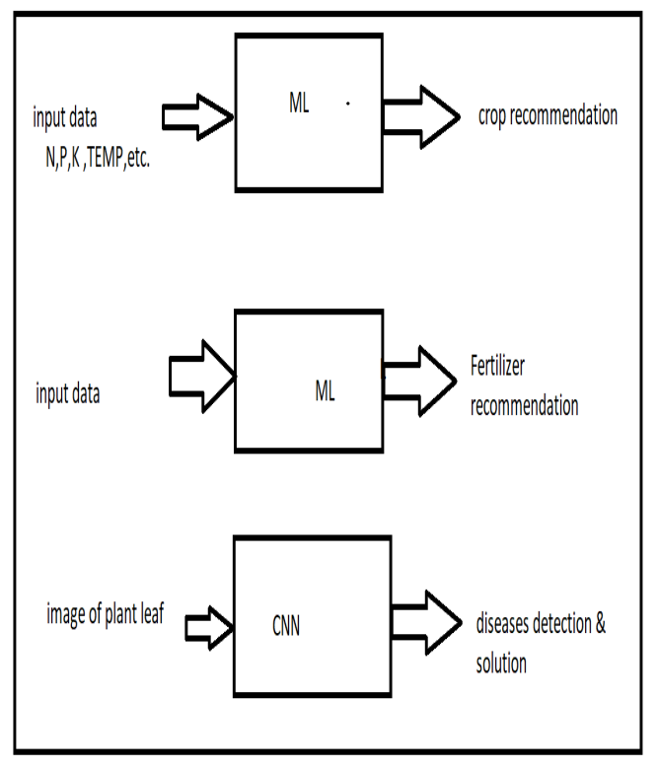

**CONCLUSION**

The food demand of the world can be meet by effective use of the available resources. The use fertilizer of right type, in right amount and at the right time can help to full the food demand of the world in an effective manner and without harming our environment such as soil and water pollution. This leads to a clean environment.

Crop production can also be increased by the right use pesticides at the right time in right quantity, which save crop from any disease.

**TABLE OF CONTENTS**

|  |  |
| --- | --- |
|  | Page No. |
| TITLE PAGE .................................................................................................................... | i |
| DECLARATION .............................................................................................................. | ii |
| CERTIFICATE …........................................................................................................... | iii |
| ACKNOWLEDGEMENT.................................................................................................. | iv |
| ABSTRACT...................................................................................................................... | v |
| LIST OF FIGURES ......................................................................................................... | vi |
| LIST OF ABBREVIATIONS ………..…………………………………………………. | vii |
|  |  |
| CHAPTER 1 INTRODUCTION | 1-n |
| 1.1.          Introduction ……………………................................................... | 1 |
| 1.2 Problem Statement .……………………....................................... |  |
| 1.2.          Objective………………………………………………………… | 2 |
| 1.3.          Scope…………………………………………………………….. | 3 |
| CHAPTER 2 LITERATURE REVIEW…………………………………………….... | 7-p |
| CHAPTER 3 PROPOSED METHODOLOGY …………………………………........ | 8-m |
| 3.1 Flowchart |  |
| 3.2 Algorithm Proposed | 10 |
| CHAPTER 4 TECHNOLOGY USED ………..………………………..………………. | 12 |
| CHAPTER 5 DIAGRAMS …........................................................................................... |  |
| CHAPTER 6 CONCLUSION …....................................................................................... |  |
| REFERENCES….............................................................................................................. |  |

**The content of the synopsis must be divided into following headings depending upon your project**

1. INTRODUCTION
2. PROBLEM STATEMENT
3. OBJECTIVES
4. LITERATURE REVIEW
5. METHODOLOGY (PROPOSED ALGORITHM /IMPLEMENTATION ACTIVITY)
6. DIAGRAMS (UML/USE CASE/ER/DFD)
7. CONCLUSION WITH RESULT
8. REFERENCES (IN IEEE FORMAT)

.